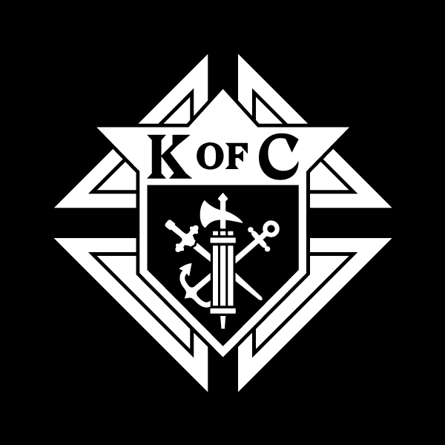 | Knights of Columbus  Advertising Application  for the 2024  Tennessee State Convention Program Booklet
Advertising format: All submissions must be in digital format. No paper copy of the ad will be accepted. (i.e. PDF, Microsoft Publisher, Word, Excel, PNG/JPEG.)
Ideas for your ad? This is a great way to show appreciation to Deacons or Priests. Celebrate council anniversary dates. Show support and recognize local Catholic School Teachers. Promote recent or upcoming Ultrasound Machine purchases. Celebrate past year accomplishments of the council. Promote upcoming council events. Use it as an opportunity to recognize members of the Parish or the Council for outstanding work.
Please email to David Comm d.comm@att.net

Due Date to have all applications and advertisements turned in is April 1, 2024.

Note: No cancellations after April 10, 2024.

Pricing for Councils, Assemblies, and Corporate Sponsors
Please mark with X:

__ ½ Page Black & White $75.00 __ Full Page Black & White $125.00

__ ½ Page Full Color $85.00 __ Full Page Color $140.00

Please Type or Print:  Name: ___________________  Council #: ________________  Phone #: _________________  Email: ___________________  Street Address: ___________  City / State / Zip: _________ | Make all checks to:  Knights of Columbus –  Tennessee State Council  Mail Checks to:  David Zwissler  C\O State Treasurer  5122 Shetland Trail  Arlington, TN 38002

We are opening our program book to sell advertising space to corporate sponsors, especially those operated by K of C members.

Please share with anyone interested! For more information and pricing details for our corporate sponsors, please contact David Comm (d.comm@att.net) to discuss.

