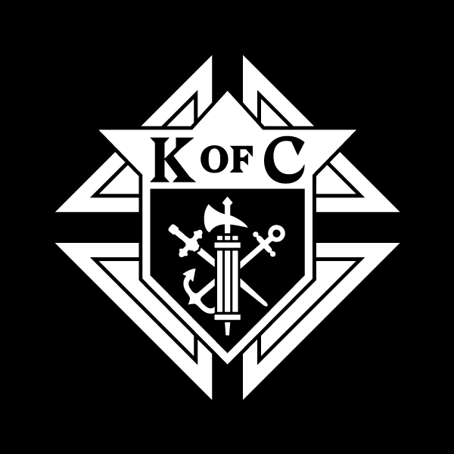
Knights of Columbus Advertising Application for the 2023
Tennessee State Convention Program Booklet

Advertising format: All submissions must be in an editable format, preferably
Microsoft Publisher, Word, or Excel.
Ideas for your ad? This is a great way to show appreciation to Deacons or Priests. Celebrate council anniversary dates. Show support and recognize local Catholic School Teachers. Promote recent or upcoming Ultrasound Machine purchases. Celebrate past year accomplishments of the council. Promote upcoming council events. Use it as an opportunity to recognize members of the Parish or the Council for outstanding work.
Please email to David Johnson at davejohnson2@comcast.net
(no paper copy of the ad will be accepted)

Due Date to have all applications and advertisements turned in is April 10, 2023.

Note: No cancellations after April 10, 2023.

Pricing for Councils, Assemblies, and Corporate Sponsors
Please mark with X:

__ ½ Page Black & White $75.00 __ Full Page Black & White $125.00

__ ½ Page Full Color $85.00 __ Full Page Color $140.00

Please Type or Print:
Name: ___________________
Council #: ________________
Phone #: _________________
Email: ___________________
Street Address: ___________
City / State / Zip: _________

We are opening our program book to sell advertising space to corporate sponsors, especially those operated by K of C members.

Please share with anyone interested! For more information and pricing details for our corporate sponsors, please contact David Johnson (davejohnson2@comcast.net) to discuss.

Tennessee State Council Office Use Only
Date Received: Amount Received: Check#:
Make all checks to: Knights of Columbus Tennessee State Council

