Tennessee State Award Packet

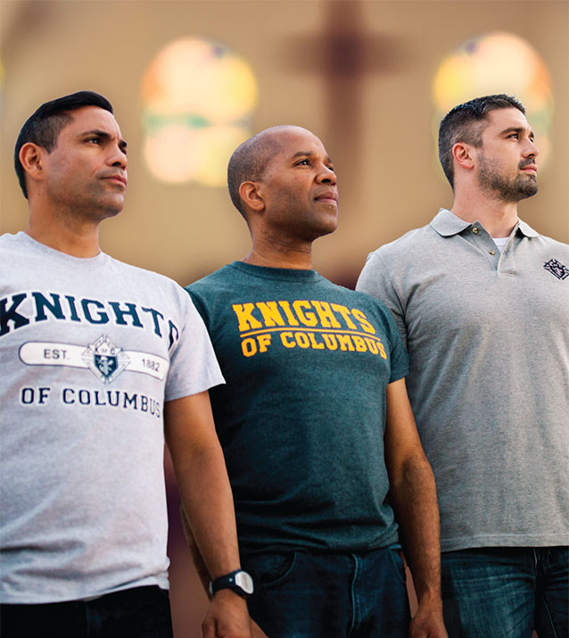
FAITH
IN
ACTION

2021/2022 Fraternal Year
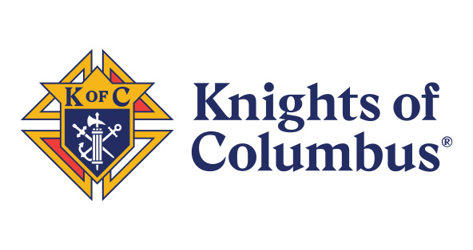

Award Applications

Document your accomplishments. Share with others the things your council has accomplished that made you proud to be a Knight.

Use Columbian Award, Family of the Month, and Family of the Year form from Supreme website.

Use State Council Forms from this guide or from the State Council Website for Bishops’ Award, Chaplain’s Award, State Deputy Award, and the Activity of the Year Awards.

Once you complete the award applications - an effective way of organizing the applications and documentation is in a binder with a cover letter and tabs for each application. One activity can be submitted in multiple categories. Another way of collectively organizing your applications is to use an USB flash drive, thus you will have an electronic copy of everything you have submitted

Remember your Family of the Year must be chosen from one of your Family of the Month designees.

Knight of the Year or Lifetime Achievement nominees should NOT be a priest.

To be considered these applications must be received by March 15th.

State Deputy Award Application
Chaplains Award Application
Bishop’s Awards Application
Knight of the Year Application
Family of the Year Application
Lifetime Achievement Application

Faith Activity of the Year
Community Activity of the Year
Family Activity of the Year
Life Activity of the Year
Kimball Award

The following lists the documentation required for the State Deputy Award, State Bishops’ Award, and the State Chaplain’s Award:

State Deputy Award Application
- Special Olympics Report
- Evidence of IRS 990 filing
- Knight & Family of the Year Nominations
- Columbia Award Application (SP-7)

State Bishops’ Award Application
- Faith –
  - FIA - Into the Breech
  - Completed RSVP Report (Form 2863)
  - FIA - Holy Hour Program
  - FIA - Vocations Awareness – Rosary Program – Marian Prayer Program
  - Copy of a monthly meeting agenda with Prayer for Vocations

- Family –
  - Listing of each Family of the Month recipient
  - FIA - Keep Christ in Christmas Activity
  - FIA - Family Fully Alive Activity or Family Prayer Night or Family Week or Good Friday Family
  - FIA - Consecration to the Holy Family
  - FIA - activities involving First Reconciliation, First Holy Communion and Confirmation
- Life –
  - FIA - participating in or sponsoring local, state, or national Right to Life March
  - Cancelled check reflecting support for a recognized Culture of Life organization or Pregnancy Support
  - FIA - Novena for Life
  - Copy of cancelled check to MR Foundation and copy of checks from MR Foundation for funds distributed – Mass for People with Special Needs
  - FIA - Silver Rose Activity – Christian Refugee Relief
  - FIA - Special Olympics Activity or cancelled check for Special Olympics donation
- Community –
  - FIA – Habitat for Humanity or Homeless Assistance Activity
  - Copy of cancelled check for Global Wheelchair Mission
  - FIA - Coats for Kids
  - FIA – Soccer Challenge and/or Free Throw Competition
  - FIA – Helping Hands

State Chaplain’s Award Application
- Parish Support (4 required)
  - Copy of parish’s Ministry Schedule highlighting or identifying Knights
  - List the Knight(s) that conduct Altar Server training
  - List the Knights that either participate in RCIA, PRE or CCD, or sponsor catechumens
  - FIA - Parish Cleanup or Beautification
  - List of Knight(s) serving on parish council, or assisting with parish administration
  - FIA - reflecting participation in one of the Rosary activities
- Spiritual Development (5 required)
  - FIA - Spiritual Reflection Activity
  - FIA - Eucharistic Adoration or Holy Hour
  - Copy of email or agenda reflecting Rosary or Liturgy of the Hours
  - FIA - Corporate Penance Service
  - FIA - Corporate Mass(es)

- Clergy Support (4 required)
  - Copy of agenda reflecting recitation of Prayer for Priests
  - FIA showing support of retired clergy or religious
  - FIA - Clergy Appreciation Activity
  - FIA - Vocation Awareness Activity for parish youth
  - FIA - reflecting organization/participation or cancelled check showing financial support for Diocesan Seminarian/Postulates Dinner
- Quarterly Meeting with Pastor – Letter from Pastor acknowledging the quarterly meetings and the council’s involvement with strengthening the parish and growing its spiritual life.

Send the completed applications to:
Dave Johnson
6024 Ashland Drive
Nashville, TN 37215
Tennessee Knight of the Year - Award Application
Personal data
Member’s Name

Spouse’s Name

Children’s Names & Ages

Street Address City State Zip

Phone E-Mail

Parish Pastor

Knights of Columbus data
Council Name Council Number

Years of Service Highest Degree

Current Position in the Council

Degree Team Member Degree Team Role(s)

Knight of the Year Criteria - Council
What was this year’s contribution to the Knights of Columbus?

Knight of the Year Criteria - Community
What was this year’s contribution to the Community?

Knight of the Year Criteria - Church
What was this year’s contribution to the Parish?

Knight of the Year Criteria -
What is the reason this Knight should receive Knight of the Year Recognition?

Tennessee Family of the Year - Award Application
Personal data
Member’s Name

Spouse’s Name

Children’s Names & Ages

Street Address City State Zip

Phone E-Mail

Parish Pastor

Knights of Columbus data
Council Name Council Number

Years of Service Highest Degree

Current Position in the Council

Degree Team Member Degree Team Role(s)

Family of the Year Criteria - Council
What was this year’s contribution to the Knights of Columbus?

Family of the Year Criteria - Community
What was this year’s contribution to the Community?

Family of the Year Criteria - Church
What was this year’s contribution to the Parish?

Family of the Year Criteria -
What is the reason this Knight should receive Knight of the Year Recognition?

Tennessee Knight – Lifetime Achievement Award Application
Personal data
Member’s Name

Spouse’s Name

Children’s Names & Ages

Street Address City State Zip

Phone E-Mail

Parish Pastor

Knights of Columbus data
Council Name Council Number

Years of Service Highest Degree

Current Position in the Council

Degree Team Member Degree Team Role(s)

Lifetime Achievement Criteria - Council
What was this Knights contribution to the Knights of Columbus?

Lifetime Achievement Criteria - Community
What was this Knight’s contribution to the Community?

Lifetime Achievement Criteria - Church
What was this Knight’s contribution to the Parish?

Lifetime Achievement Criteria -
What is the reason this Knight should receive Lifetime Achievement Recognition?

Tennessee State Deputy Award Requirements
COUNCIL # ______

All Items Are Required, and must include paperwork as requested

- Report of Council Officers (Form #185) completed and returned to the Supreme Office with copies sent to the State Secretary and District Deputy, postmarked by August 1st

- Service Program Personnel Report (Form #365) completed and returned to the Supreme Office with copies sent to the State Secretary and District Deputy, postmarked by August 31st

- Semiannual Audit Report (Form #1295) for June 30th completed and returned to the Supreme Office with copies to the State Secretary and District Deputy, postmarked by August 31st

- Annual Survey of Fraternal Activities (Form #1728) completed and returned to the Supreme Office with copies to the State Secretary and District Deputy, postmarked by January 31st

- Semiannual Audit Report (Form #1295) for December 31st completed and returned to the Supreme Office with copies to the State Secretary and District Deputy postmarked by February 15th

- Award application for your Council’s “Knight of the Year” completed and mailed to the General Program Consultant postmarked by March 15th.

- Award application for your Council’s “Family of the Year” completed and mailed to the General Program Consultant postmarked by March 15th.

- Copy of Special Olympics (Form #4584) by January 31st

- Copy of Tax form 990 filed by May 1st
- Copy of Award application for the Columbian Award (Form #SP-7) completed and ready to submit to the Supreme Office (some items may not have been completed by 3/15) – assumes it will be submitted on or before 6/30 to Supreme.

- At least one representative from your council, MUST attend the
    - State Kick off,
    - Mid-Year,
    - District meeting, and the
    - State Convention.

Due March 15th to State Program Director item # 9 & 10
No application, just send in copies of the three items
Other criteria will be tracked by the state program staff

Kimball Award (Preferably Council Life Director)
How does this knight advocate for life in the council, church, family, and community?

Involvement
Describe involvement with a pro-life organization such as TN Right to Life, 40 Days for Life, Priests for Life, marchforlifeaction.org, Susan B Anthony list, Students for Life or other pro-life 401(c) organization.

Advocates
Describe how this knight Advocates for pro-life legislation in community or at State and/or National Level.

Prayer
Describe how this knight Consistently prays for the unborn and those who are vulnerable, including Persecuted Christians and persons with disabilities.

Tennessee State Chaplain’s Award

Documentation Required for Completion of Activities
Parish Support (4 of the 6 are required)
- Promote increase in number of Knights serving as Ushers, Eucharistic Ministers, and Lectors.
- Conduct Altar Server training for your Parish.
- Knights participation in RCIA and/or sponsoring catechumens or participating in your parish’s PRE/CCD program.
- Knights to serving on Parish Council.
- Sponsor Parish Cleanup.
- Leading one of the parish’s Fifth Sunday Rosary, leading parish weekly Rosaries, or participation in the Family Rosary Program.

Spiritual Development (All 5 are required)
- Spiritual Reflection Program – Under the guidance of your chaplain, the council plan opportunities for prayer and reflection together as a fraternity. Councils can attend a retreat or day of reflection together or perhaps organize a spiritual program event for the men of your parish.
- Eucharistic Adoration / Holy Hour – Eucharistic Adoration: If your Parish does NOT have Eucharistic Adoration, then start a mission or work with your pastor to organize regular holy hours of Eucharistic adoration. KofC holy hours could be particular prepared for men, complete with preaching, a communal rosary, and prayers to St. Joseph and Fr. McGivney. If your Parish already has Eucharistic Adoration, then Knights MUST have regular participation in the Parish Eucharistic Adoration.
- Rosary or Liturgy of the Hours before Meetings
- Corporate Penance Service – Work with your pastor or chaplain to plan and execute a Corporate Penance Service for your council. Ideally this would take place during the Lenten season.
- Knights Mass with Corporate Communion

Clergy Support (4 of the 5 are required)
- Prayer for Priests – Recite the prayer during the Rosary or Liturgy of the Hours before the meeting, or with the Prayer for Vocations during the meeting.
- Support Clergy Retirement – Provide occasional meals, doing yard work, or visiting with retired clergy or religious are but a few examples.
- Conduct Clergy appreciation program –
- Conduct Vocations Promotional Program for Parish Youth –
- Support Annual Diocesan Seminarian or Postulates Dinner – Support by organization, providing manpower, or providing at least $300 financial support.
Quarterly Meeting with Pastor – REQUIRED – In order to strengthen our parishes, the council’s goals and activities should align with the pastor’s. A letter from your pastor or chaplain acknowledging the quarterly meetings and how the council is working to help strengthen and grow the spiritual life of the parish is required.

Due March 15th to State Program Director of each fraternal year
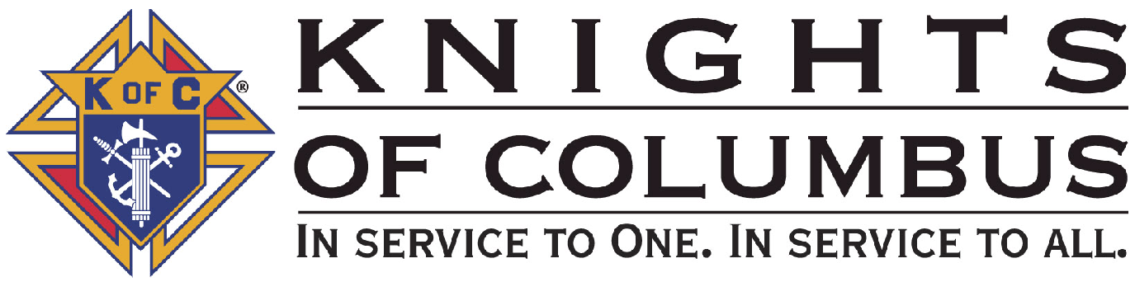 | Tennessee State Chaplain’s Award
 | ENTRY FORM
FROM COUNCIL NAME: NUMBER: .

PARISH:_____________________________________________ CITY _______________________________

GRAND KNIGHT: TELEPHONE: __ .

EMAIL: . ___________________________________________________________________________________

Council Leadership (GK minimum) Meeting Quarterly with Pastor (List dates):

- _____________ 2) _______________ 3) ______________ 4) _________________

Parish Support
- _______________________________________________________________
- _______________________________________________________________
- _______________________________________________________________
- _______________________________________________________________

Spiritual Development
- _______________________________________________________________
- _______________________________________________________________
- _______________________________________________________________
- _______________________________________________________________
- _______________________________________________________________

Clergy Support
- _______________________________________________________________
- _______________________________________________________________
- _______________________________________________________________
- _______________________________________________________________

Attach any needed support info for above (i.e. copy of bulletin listing programs, minister schedules, dates of activities, letter from pastor, photos, etc.)

MAIL ORIGINAL TO STATE PROGRAM DIRECTOR by March 15th
COPY TO COUNCIL FILE
DO NOT SUBMIT THIS REPORT FORM TO SUPREME COUNCIL

Tennessee State Bishops’ Award

Documentation Required for Completion of Activities
Faith (4 of the 5 are required)
- RSVP – Adopt a seminarian, and communicate regularly providing spiritual, moral, and financial support. Notify the Bishop through the diocesan vocations office and provide the Bishop with periodic updates.
- Recite the Prayer for Vocations at each council meeting.
- Into the Breach – Start reflection and study groups using the guide printed in the book. Solicit all men in the parish to participate, including those that might not yet be of our faith.
- Holy Hour – Work with pastors to organize regular holy hours of Eucharistic Adoration. KofC holy hours could be particular prepared for men, complete with preaching, a communal rosary, and prayers to St. Joseph and Fr. McGivney.
- Sponsor a Vocations Awareness Mass and Information Day. Distribute copies of the Prayer for Vocations at the Mass, and ask Father to recite it before the end of Mass with the entire Congregation joining in. Distribute Vocations pamphlets after Mass to all those who are interested.

Family (4 of the 5 are required)
- Name a “Family of the Month” each month. Submit FOM Certificates to Supreme by deadline date. From the monthly “Family of the Month” winners, select a “Family of the Year” and nominate the family for the Tennessee Family of the Year Award.
- Family Fully Alive – The Family Fully Alive program provides monthly themes, reflections, meditations and family projects to help each family place God and the Catholic faith at the center of its life. Used as a devotional for all families throughout the liturgical year.
- Consecration to the Holy Family – Councils invite families of their parish to offer the prayer of Consecration to the Holy Family through which families invoke the protection of the Holy Family. A traditional recommendation is that this take place on the feast of the Holy Family, typically the first Sunday after Christmas.
- Keep Christ in Christmas – (Posada, Poster Contest, Creche Blessing/Tree Lighting, etc) – A collection of activities that promote the season of Advent and Christmas in their proper context, centered on the nativity of Jesus. Through a variety of activities, councils promote the “true spirit” of Christmas in our homes, schools, and communities, and they evangelize society through their faithful acts and celebrations.
- Participate in your parish’s First Reconciliation, First Holy Communion, and Confirmation.

Life (4 of the 5 are required)
- Send a representative to a local or national Right-To-Life March.
- Provide a recognized Culture of Life organization with financial or manpower assistance.
- Novena for Life – The protection of life is a sustained prayer intention of the Church and our Knights of Columbus councils. A council can promote 9 days of prayer for a culture of life both in the parish and in our homes. These novenas could proceed or end with major feast days or pro-life events.

Tennessee State Bishops’ Award – Continued

Life Continued (4 of the 5 are required)
- Participate in the MR Campaign by raising funds for the current year and distribute the previous year’s funds.
- Silver Rose – Eight silver roses now take various routes across the North American continent from Canada to Mexico. Every pilgrimage stop of the rose is an occasion for prayer and spiritual renewal centered on the rosary. The events share with participants the message of Our Lady of Guadalupe.

Community (4 of the 5 are required)
- Homeless Assistance – Councils are encouraged to organize or participate in a program that addresses the needs of those who are homeless in their community with the intention to provide them dignity, hope, and love. Activities include cooking soup kitchen meals, volunteering or operating a food pantry, and participating in mission trip as a parish.
- Global Wheelchair Mission – Councils are encouraged to donate at least $150 for a wheelchair. Through partnerships, councils can purchase a case of at least 100 wheelchairs for their own donation sites.
- Coats for Kids – Councils across North America can purchase new winter coats for children of low-income families at a discount and to distribute them to families in need in their local communities. Coats purchased at a cost of US$220 per case of 12 coats. In order to qualify for the Bishops’ Award, coats do not need to be purchased from Supreme.
- Special Olympics – Participation with local or state Special Olympics events (more than 100 combined man hours), hosting awards dinners, or a financial contribution of $500 or greater to a local or state chapter.
- Promote, organize, and conduct a movement or project to assist the physically and mentally challenged in your Council area or community.

Due March 15th to State Program Director of each fraternal year

Tennessee State Bishop’s Award
ENTRY FORM
FROM COUNCIL NAME: NUMBER: .

PARISH:_____________________________________________ CITY _______________________________

GRAND KNIGHT: TELEPHONE: __ .

EMAIL: .

________________________________________________________________________________

Faith Activities
1) _______________________________________________________________
2) _______________________________________________________________
3) _______________________________________________________________
4) _______________________________________________________________

Family Activities
1) _______________________________________________________________
2) _______________________________________________________________
3) _______________________________________________________________
4) _______________________________________________________________

Life Activities
1) _______________________________________________________________
2) _______________________________________________________________
3) _______________________________________________________________
4) _______________________________________________________________

Community Activities
1) _______________________________________________________________
2) _______________________________________________________________
3) _______________________________________________________________
4) _______________________________________________________________

Attach any needed support info for above (i.e. copy of bulletin listing programs, dates of activities, letter from pastor, photos, form 10784, SP-7 etc.)

MAIL ORIGINAL TO STATE PROGRAM DIRECTOR by March 15th
COPY TO COUNCIL FILE
DO NOT SUBMIT THIS REPORT FORM TO SUPREME COUNCIL

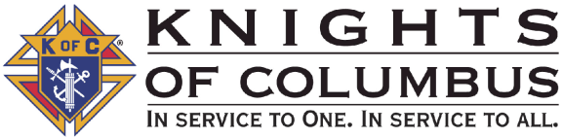 | DISTRICT DEPUTY AWARD APPLICATION
 | ENTRY FORM
THIS REPORTING FORM MUST BE COMPLETED BY EACH DISTRICT DEPUTY AND FORWARDED TO THE STATE PROGRAM DIRECTOR.

FROM DISTRICT DEPUTY: TELEPHONE: .

EMAIL: District Number: .

PROJECT TITLE: ________________________________________________________________________________

COUNCIL NAME: COUNCIL NUMBER: .

LOCATION: .
TOWN OR CITY STATE
PURPOSE OF ACTIVITY: (In the space provided below, describe in one sentence the purpose of this activity, and how this activity supported the state council’s theme and or goals. This section must be completed.)

Date(s) of the Project or Activity …………………………………………………. .

Number of council members participating in this project.………………………. .

Percentage of council members participating in this project….……………. % .

Number of man hours expended in project: …………….………………………. .

Chairman’s Name: TELEPHONE: .

Grand Knight’s Name: TELEPHONE: .

MAIL ORIGINAL TO STATE PROGRAM DIRECTOR by March 15th
COPY TO DISTRICT DEPUTY FILE and COUNCIL FILE

DO NOT SUBMIT THIS REPORT FORM TO SUPREME COUNCIL

 | STATE ACTIVITY AWARDS
 | ENTRY FORM
THIS REPORTING FORM MUST BE COMPLETED BY EACH COUNCIL AND FORWARDED TO THE STATE COUNCIL.
(A SEPARATE REPORTING FORM SHOULD BE COMPLETED FOR EACH PROGRAM CATEGORY.)

CATEGORY (MARK ONE): FAITH COMMUNITY VOCATIONS

FAMILY LIFE

FROM GRAND KNIGHT: TELEPHONE: .

EMAIL: .

COUNCIL NAME: NUMBER: .

LOCATION: .
TOWN OR CITY STATE
PROJECT TITLE: _________________________________________________________________ .
DATE PROJECT CONDUCTED: _______________________________________________________ .

PURPOSE OF ACTIVITY: (In the space provided below, briefly describe the purpose of this activity. This section must be completed.)

Number of council members participating in this project ……………………..…………. .

Percentage of council members participating in this project: ………………………. % .

Number of man hours expended in project: ……………….……………….……..……. .

Chairman’s Name: TELEPHONE: ____________________

MAILING ADDRESS: ____________________________________________________

EMAIL: ________________________________________________________________

MAIL ORIGINAL TO STATE PROGRAM DIRECTOR by March 15th
COPY TO COUNCIL FILE

^{CONTINUE ON NEXT PAGE}

Describe project in detail. Use additional paper if necessary. Supplementary material may be submitted along with the nomination. Accompanying materials can include letters, testimonials, news clippings, photographs, pamphlets, etc. Do not submit tapes, videocassettes, DVD’S, display materials, films, etc., as they will not be considered in judging the nomination.
Describe below the membership component of this activity

ATTEST: _______________________________ Signed:_________________________________
(State Deputy) (Grand Knight)
DO NOT SUBMIT THIS REPORT FORM TO SUPREME COUNCIL

ENTRY MUST BE RECEIVED BY THE STATE COUNCIL
TO BE ELIGIBLE FOR THE COMPETITION

For more information on the Service Programs go to www.kofc.org

STATE COUNCIL MEMBERSHIP PROGRAM AWARD
ENTRY FORM
FROM GRAND KNIGHT: TELEPHONE: .

EMAIL: .

COUNCIL NAME: NUMBER: .

LOCATION: .
TOWN OR CITY STATE

The Goal is for every eligible catholic man to be given an opportunity to become a Knight of Columbus
The Program is divided into four areas: Organization, Strategy, Recruitment & Retention to be eligible you should score points in each category and a minimum of 100points required

I. Organization (5 points each)
Membership Chairman
Membership Committee
Admission Committee
Retention Chairman
Retention Committee

II. Planning (5points each)
One New Member each Month
Officers Challenge One New Member
Parish Membership Drive
Membership Invitation by Mail
Develop and Use a Prospect List
Fraternal Benefits Night for Parish
Recruit Former Members
Recruit Transfers into Area
Recruit RCIA

Recruit Young Men
Boy Scouts
Recruit Young Men
Squires
Degree Team
Shining Amour Program
Sponsorship Program

Other

III. Recruitment (5 points each for Jul-Sep; 3 points each Oct-Dec; 1point each Jan-Mar)

Membership Challenge | Jul | Aug | Sep | Oct | Nov | Dec | Jan | Feb | Mar
# of New members each month
# of First Degree Hosted each Month
# Advance to 2nd Degree each Month
# Advance to 3rd Degree each Month

Annual Membership Goal: ______

IV. Retention (Goal no more than 5 suspensions per council with 5 points each member retained)
Retention Activity | Date | Result
Number of Knights in arrears / inactive
Number of Knight Alerts
Number of personal contacts
Number of reactivated Knights
Number of Suspensions
Suspension as % of total members
MAIL ORIGINAL TO STATE PROGRAM CHAIRMAN
COPY TO COUNCIL FILE

ATTEST: _______________________________ Signed:_________________________________
(State Deputy) (Grand Knight)
DO NOT SUBMIT THIS REPORT FORM TO SUPREME COUNCIL

ENTRY MUST BE RECEIVED BY THE STATE COUNCIL
TO BE ELIGIBLE FOR THE COMPETITION

State Program

Forms/Applications

FORM & NUMBER # | COMPLETE | DATE REQUIRED 3/15 | MAIL TO
Bishops Award Application |  |  | State Program Director  Dave Johnson  6024 Ashland Drive  Nashville, TN 37215  programs@kofc-tn.org  davejohnson2@comcast.net
State Chaplain Award Application
State Deputy Award Application
Lifetime Achievement Award App.
Knight of the Year Application
Family of the Year Application
Faith Activity of the Year
Community Activity of the Year
Life Activity of the Year
Family Activity of the Year
Vocation Activity of the Year
Charity Activity of the Year
Membership Program of the Year

State Officers
